**Part 4 - Routing**

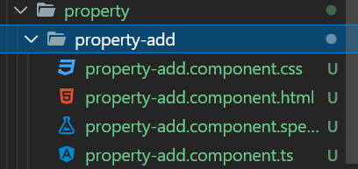

First one, please create property-add component

**Open app.module.ts**



Import above component



Import these modules

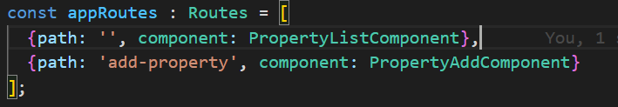

Define the route path

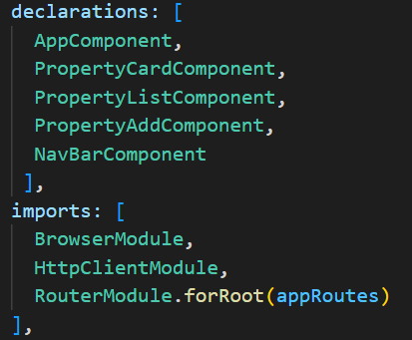

Register component and route path

Open app.component.html

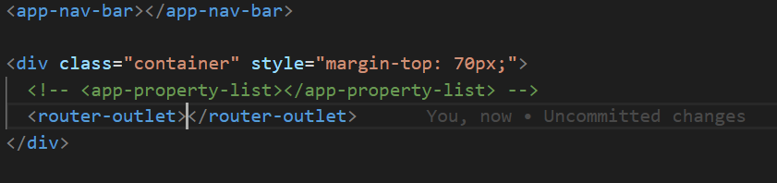

Router outlet like a replacement template. Once we click the route in URL address , then content of component will be displayed within router outlet

Open nav-bar.component.html

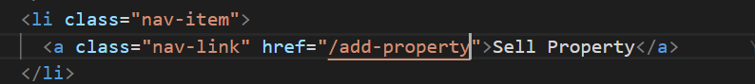

This href value likes route path that we have defined in app.module